Python Arrays / Lists

Please complete all the tasks using python and attach a screenshot of your completed code.

**Student ID**: Click or tap here to enter text.

**Full Name**: Click or tap here to enter text.

# Resources

1. <https://www.quackit.com/python/tutorial/python_lists.cfm>

# Tasks

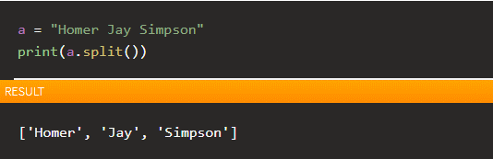

1. Observe the above code and Resource 1.
2. Develop an application that can accept an input from the user and output how many words they have entered. **Attach a screenshot of your code below.**

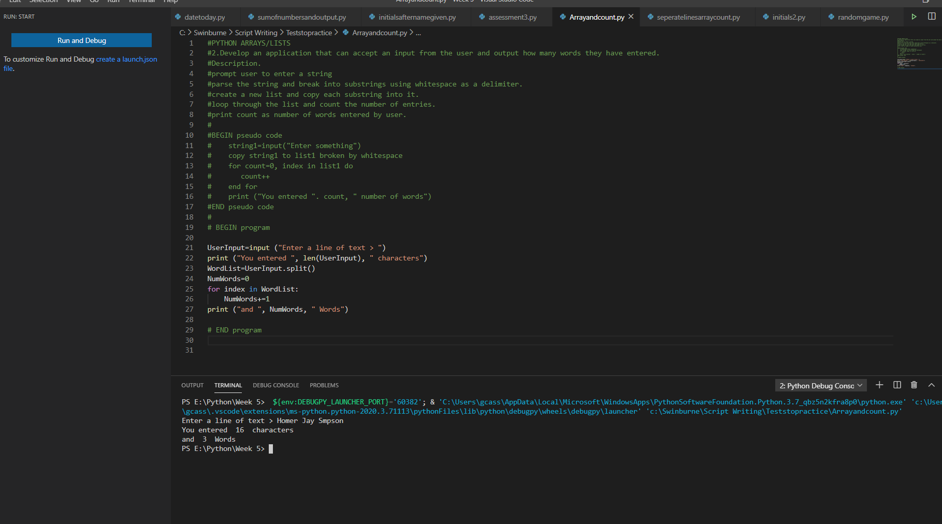

Continued next page

1. Modify your above code to output the below on separate lines. (Refer back to resource 1 if you are struggling). **Attach a screenshot of your code below.**
   1. The first word
   2. The 3rd word (if there are 3 or more words)
   3. Every word excluding the first and last one (if there are 3 or more words)

First is just a program that shows output on different lines. Second screenshot answers a.b. & c.

